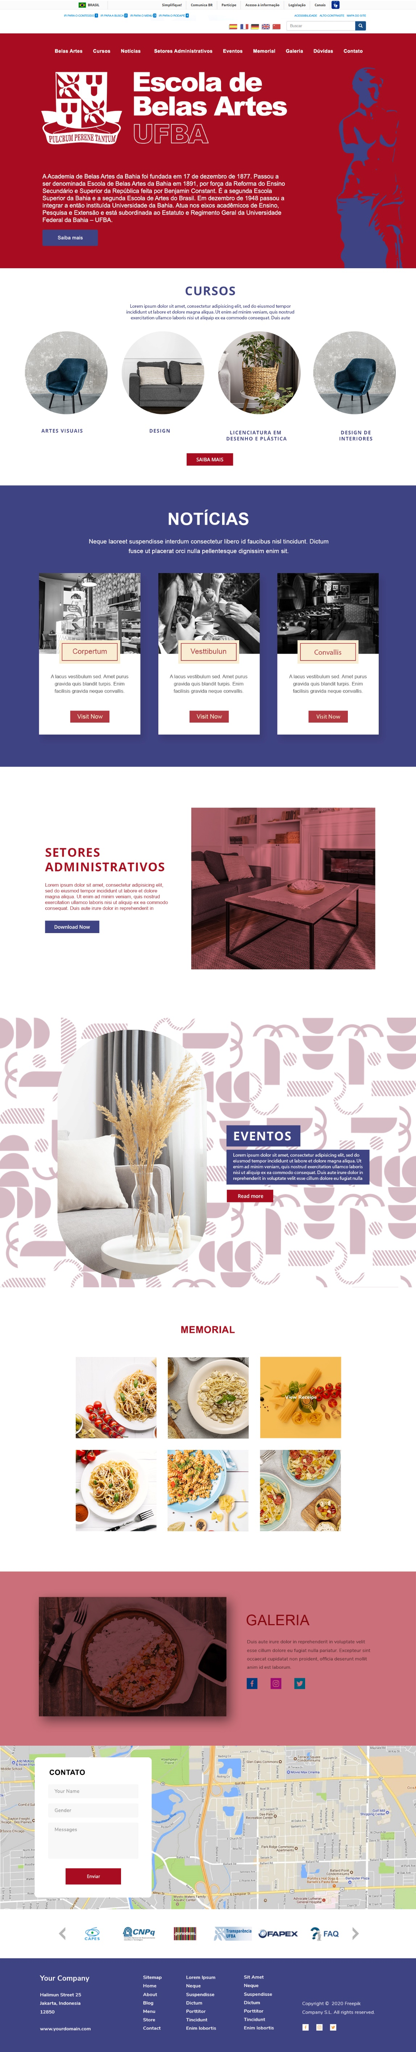

https://docs.google.com/document/d/1_A4kkGud-YB7QUY9EpTIFiB8b19ZznHxpDHFyMSvcac/edit?usp=sharing

